1.Open the "package" new project button, "mode" mode edit the button "control" controller to edit the button "language" language choice
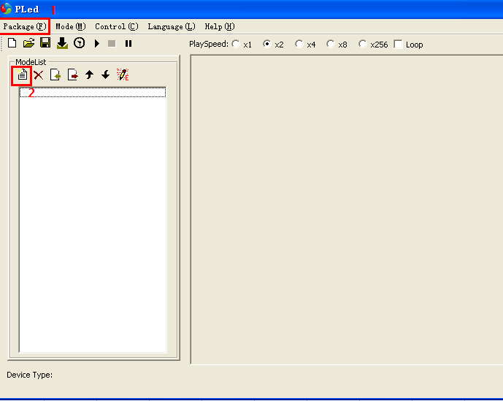
2.Click "package" to create a new project and click the "1" channel number to be set according to the requirements, and the other options are unchanged.
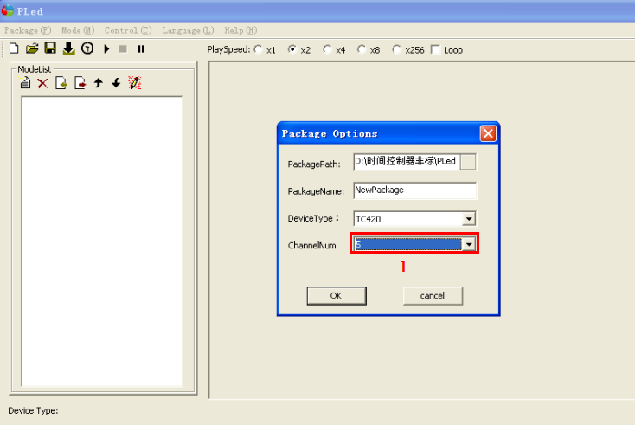

3.Click "1" to create a new mode and click "2" to set the mode. Mode Settings interface, click "3"To set the number of pattern scenarios. Click "4" to set the mode scenario trigger time. Click "5" to set the mode type to jump or gradient. Click "6" to set the brightness value of the pattern scenario.
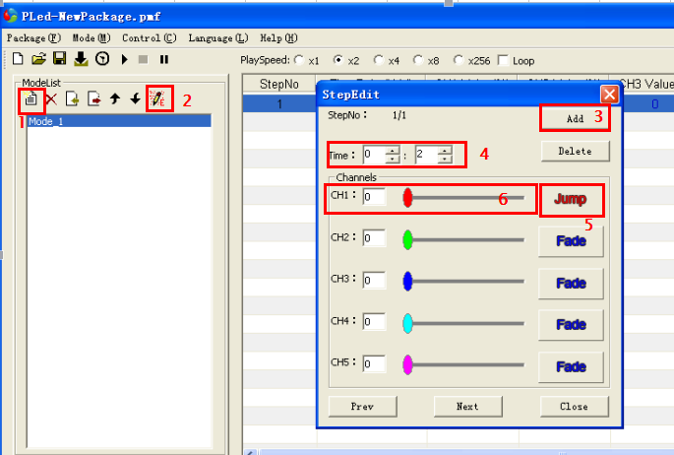

4.Model set up later, click on the "1" to save the already set a good model (without saving it is impossible to set a good model to download to the controller), click on the "2" to download the model into the controller, click 3 to synchronous control is consistent with the PC time, click on the "4" good pattern effect can be set to browse.
