DL113 DALI DMX512 Signal Converter

Production Specification

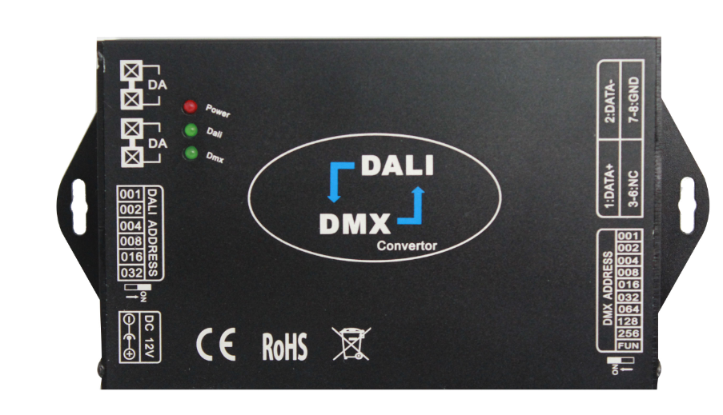

SHENZHEN LEYNEW TECHNOLOGY CO., LTD
1.Summarization
DALI (Digital Addressable Lighting Interface) is an international standard, popular lighting control protocol BUS, which adopt to Manchester codes of digital transmission, with a whole and grouping dimming, addressing dimming, inquire lamps and lanterns sates, and other powerful dimming function. Compared with the 0-10V analogue dimming, it’s more precise dimming, addressable, stable, focus control, easy to installation and so on.
DMX512 is first by USITT (American theater technology association) develop and become from the console with standard digital interface control dimmers way. It has simple, reliable, flexible features.
The product can achieve conversion between standard IEC62386 DALI dimming signal and widely used DMX-512 standard signal, realize DMX module control by DALI master, and also can realize DALI device control by DMX master, realize 2 kinds protocol seamless transition.

2.Features
① Support DMX512 to DALI / DALI to DMX512 signal conversion;
② Support DIP switch selecting DMX initial address;
③ Support DIP switch selecting number of DALI channel;
④ Supports maximum 64 DALI signal outputs;
⑤ Support group control and scene control of DALI device, the function is effective under mode of DALI to DMX signal.

3.Technical parameters
3.1 Working temperature: -20-60℃
3.2 Supply voltage: DC12V-48V
3.3 Input signal: DALI/DMX512
3.4 Output signal: DMX512/DALI
3.5 Statical power consumption: <1W
3.6 Connection mode: 4pin green connection pillar for DALI signal, RJ45 interface for DMX signal.
3.7 External dimension: L150mm*W78mm*H26mm
3.8 Packing dimension:L180*W108*H55mm
3.9 Net weight:209 g
3.10 Gross weight:277 g

4.External dimension
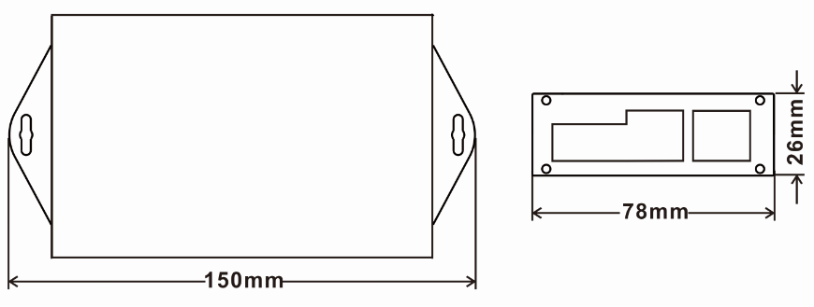
5.Instructions
5.1 Interface Specification
Power interface: DC12-48V
DALI interface: connect DALI bus, no positive and negative difference
DMX interface: RJ45 interface, differentiate positive and negative difference.
5.2 Indicator light Specification
Power: power indicator light, long light on behalf of the controller access to the power supply polarity
is correct, work normally; off on behalf of the power reverse or the controller is not working properly.
DALI: DALI indicator light, flicker on behalf of the data being converted, long light representative no data conversion, representing no DALI signal access.
DMX: DMX indicator light, flicker on behalf of the data being converted, long light representative no data conversion.
5.3 DIP Switch Specification
DALI address: 6 dial switches, used to set the DALI channel output. For example, if you set all the dial codes to OFF, it can realize DALI control of A0 address. If you set 001 to ON and the other dial codes set to OFF, it can achieve DALI control of A0 and A1 addresses. To control 64 channels Of the DALI equipment, the six DIP switches are set to ON, A0 - A63 to achieve a total of 64 addresses DALI control. (Note 1)
DMX address: 10 dial switches, 10th to lower ADDRESS, and so on.
Fun: FUN is used to switch the conversion mode, OFF is DALI to DMX512, ON is DMX512-DALI.
001-256 dial Code Used to set the start address of the DMX signal. DMX minimum starting address is 1. For example: when the DIP switch is OFF, the DMX start address is 1; when the DIP switch is set to ON, and the other is OFF, the DMX start address is 1 + 1, which is 2; when all the DIP switches When set to ON, the starting address is 511 + 1, which is 512. (Note 2)
Note 1: DALI devices address A0 to A63, a total of 64 device addresses;
Note 2: DMX channel address is 1 to 512, a total of 512 channel address;

5.4 Functional description
① DALI convert DMX signal dimming curve is converted to a linear dimming.
② DMX dimming curve is linear, convert DALI dimming signal curve is logarithm way.
③ FUN is used to switch the conversion mode, ON is DMX512-DALI, OFF is DALI to DMX512.
④ DALI DIP switch: it is used to set number of DALI channels, for example: set to 30, the converter will control only 31 channels of A0-A30.
⑤ DMX DIP switch: it is used to select the start address of the DMX signal, which is controlled by the DALI signal from the start address to the end address (start address + DALI output address). At the same time, the number of controlled channels is limited by DALI DIP switch. For example: DMX DIP switch is set to ADDR=10, DALI DIP switch is set to 30,
the DALI address A0 corresponds to the DMX address is ADDR, and the A1 corresponds to the address ADDR+1 ...... The A30 address is ADDR+30 (maximum is 512), The address of A30-A63 will no longer be controlled. DMX and DALI address mapping table is as follows:

DMX address (maximum512) | DALI address | DMX address (maximum512) | DALI address
ADDR+1 | 0 | ADDR+8 | 7
ADDR+2 | 1 | ADDR+9 | 8
ADDR+3 | 2 | ADDR+10 | 9
ADDR+4 | 3 | … | …
ADDR+5 | 4 | ADDR+63 | 62
ADDR+6 | 5 | ADDR+64 | 63
ADDR+7 | 6
6.Typical Application
DALI to DMX512:
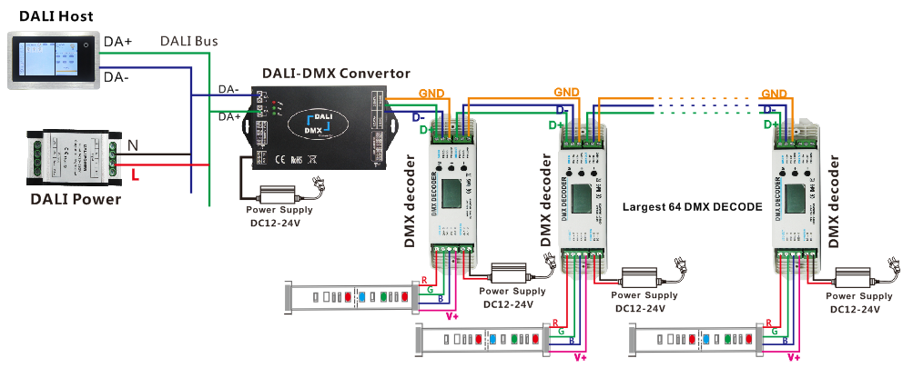
DMX512 to DALI:
